Analysis of Rising Medical Costs: A Briefing Paper
Name of Author:
Institution:
Date:

A Brief Overview
Dear Senator Marilynn, I hope my briefing paper finds you in good health. I intend to give you more insight on the state of medical cost in our great nation over the years. As well known to everyone, medical services are critical to not only to supporting livelihoods but also vital in the pursuance of the American dream. In your duty to your constituents and the American people in general, the dedication to improve lives is a noble cause in the progression of the nation. In recent years, all indications have proved that the medical costs have rapidly risen and more of these crucial services are becoming unaffordable to millions of Americans. This is very dangerous precedent because a successful nationhood bases on health and wellness. In this briefing paper, I lay down the facts on this phenomenon and utilize the indifference curve analysis, an economic approach, to explain it more. Finally, I will lay a couple of proposals on what can be done to reverse the trend.
The Rising Trends in Medical Costs
In general medical costs are the consumers’ expenses in treating or preventing injuries or illnesses and includes prescriptions, hospital visits and health insurance premiums. For the taxpayers, these tax-deductible costs are fundamental in pursuing wellness and their affordability is a goal for everyone. High costs mean that the people can no longer afford the much needed healthcare which poses significant risks to their well-being. The US, unlike other nations, have significantly higher costs which lays immense burden on the taxpayers (Leonhardt, 2019). Essentially, both academia and health research have indicated a steady rise in the medical costs over the decades. For instance, the Quarterly Services Survey (QSS) offers a measuring tool to understand how the costs have changed over the years. A recent summary of the trend in the medical cost is outlined in figure one below;
Figure 1: Total National Health Expenditures, US $ Billions, 1970-2019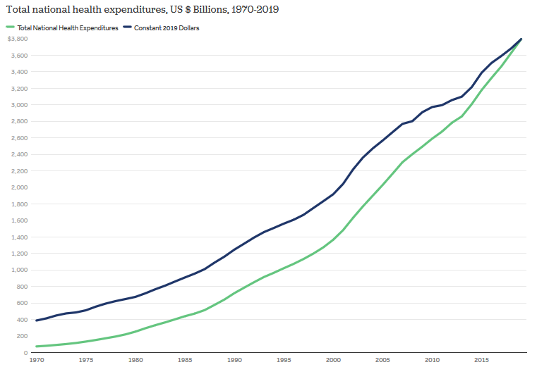
Source: Kamal et al. (2020). Retrieved from https://www.healthsystemtracker.org/chart-collection/u-s-spending-healthcare-changed-time/#item-start
From figure 1 above, in 1970, the Americans spent about $74.1 billion on healthcare spending and by the turn of the new millennium, the costs had risen up to $1.4 trillion. As years moved on, the costs continually rose exponentially resulting in $3.8 trillion by 2019, which represents threefold in total health expenditures for the year 2000 (Kamal et al., 2020). Additionally, concerning the per capita basis, the QS survey outlined that the spending on healthcare is now 31-fold in the four decades from 1970 to 2019. A typical American spent about $353 on healthcare in 1970, a figure that has risen to about $11,582 in 2019 (Kamal et al., 2020).
Further on, in expressing the healthcare findings as the percentage of the Gross Domestic Product (GDP), the data from National Health Expenditure by the Centers of Medicare and Medicaid Services reveals a similar trend. The summary of the data is presented in figure 2 below. From the figure, the expenditures have steadily risen over the decades. In 1960, for instance, Americans spent on medical expenses equivalent to 5 percent of the GDP which have upped to 18 percent of the GDP in 2018. Ideally, the Centers for Medicare and Medicaid Services anticipate that the costs would rise exponentially and by 2028, an average American will spend about $18,000 on medical care services which would result in a cumulative figure of $6.2 trillion accounting for about a fifth of the national GDP (PGPG.Org, 2020).
Figure 2: National Health Expenditures as % of GDP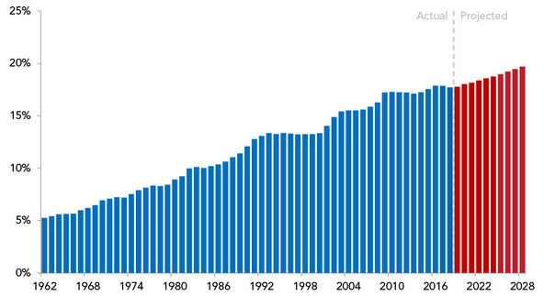
Source: Peter G. Peterson Foundation (PGPG.Org) (2020). Retrieved from https://www.pgpf.org/blog/2020/04/why-are-americans-paying-more-for-healthcare

The Impact of Covid-19 on Healthcare Costs
Yet, it is vital to emphasize that these figures do not account for the Covid-19 pandemic, whose emergence placed more burden on the consumers. A late 2020 scholarly study has outlined that the Covid-19 related aspects such as hospitalization, need for ventilators, closer medical attention and mental health illness further increase the per capital costs in medical care (Chen et al., 2020). Another study basing on modelling revealed that up to a fifth of the population may be asymptomatic requiring about 11.2 million hospital visits resulting in 62.3 million hospital bed days and the use of 1.6 million ventilators. The direct costs attributable to the Covid-19 pandemic would range between $163.4 billion and $654 billion during the course of the pandemic (Bartsch et al., 2020). Other surveys such as Lively have outlined that about 52 percent of US adults admitted that rising health costs have impaired or delayed their daily activities with a quarter acknowledging an effect on their long term goals and aspirations (Leonhardt, 2019). The same survey reveals that medical cost are the leading cause of personal bankruptcies in the country. The situation has become dire that about 250,000 medical campaigns have been listed on GoFundMe annually, pooling together about $650 million to help households manage the costs (Leonhardt, 2019). In summary, the costs are constantly rising and they pose great risks and burden on the American consumers.
The Indifference Curve Analysis
This is basically an economic concept that compares how a consumer selects through two commodities that offer equal levels of utility University of Minnesota, 2016). It is outlined in form of a down sloping curve as seen the following figure. The general assumption is that the points along the curve generate same utility levels which means a consumer is indifferent between the two commodities. In this case, we take M to be the healthcare (as a commodity) while X represents a total range of commodities that are non-medical, but definitely promote the consumer’s quality of life. Given the consumer’s income Y, the utility function would be Y= P_{m}M + P_{x}X where P_{m} is the price of medical care, M, while P_{x} is the price of other commodities. It is important to note that consumers operate within a budget constraint due to limited financial resources.
Figure 3: Typical Indifference Curve- Healthcare vs other commodities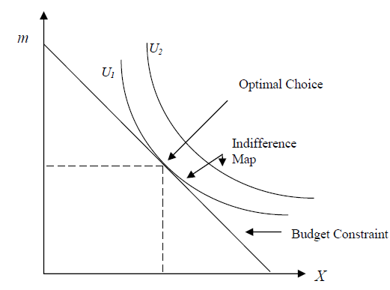
Source: Leo (2014), p. 2
In the illustration above, the optimal choice represents the quantity of the two commodities that consumers can purchase or afford (M and X). The points along the first indifference curve U1 represents the utility by which a consumer can buy both goods. Any points below this curve shows inferiority while the outer region is preferred. In the case where medical costs are high and consumers no longer affords, there is an imbalance in utility which means that the consumers will forego the medical costs (Leo, 2014). In such a case the combination of M and X are inferior and the consumer will no longer be able to substitute M for X to get same satisfaction. In other words, the marginal rate of substitution (that is, maximum quantity of a commodity consumers are willing to give up so as to obtain an additional unit of the other commodity), is critically overstretched (Mühlbacher et al., 2016: University of Minnesota, 2016). In essence, it is what is happening to most of Americans today owing to high costs of medical care. More of them are now unwilling to invest in M for additional units of X. Basically, it is becoming more burdensome to seek good quality go medical care in relation to expanses such as food, housing expenses, and college fees, starting/running a business or saving for retirement among others. Despite the critical nature of healthcare services, many people would rather avoid, delay these services or seek substandard care (like over the counter drugs) due to other pressing needs. Dear senator, this presents a grim picture of a population overwhelmed by high medical costs as many continue to take unhealthy choices.
Conclusion & Recommendations
It is well documented that the costs of medical care have gone up incrementally over the years. The projects indicate the trend will continue piling more burden on the American consumers. It is vital to seek bold legislation moves to save the American people, especially those in the lower class cadres. In effort to keep the medical expenditures lower, the following couple of proposals could be impactful. Firstly, the Senate need to seek alternative funding sources to invest more in the healthcare sector which will widen coverage. This would especially help the lower class Americans who are unable to afford the current healthcare insurance. More funds will cushion them by making healthcare more affordable. Secondly, the senate can pass specific laws to take costs out of the system. There is high differentiation in the costs of healthcare services from one institution to another. Usually drugs and healthcare procedures are greatly overpriced which makes affordability a problem. A standardization legislation would be a welcome move to ensure the variation in costs are minimal and more people can afford these services.

References
Bartsch, S., Ferguson, M., McKinnell, A., O'Shea, K., Wedlock, P., Siegmund, S., and Lee, Y. (2020). The Potential Health Care Costs And Resource Use Associated With COVID-19 In The United States. Health Aff (Millwood), 39(6):927-935. Doi: 10.1377/hlthaff.2020.00426.
Chen, J., Vullikanti, A., Hoops, S. et al. Medical costs of keeping the US economy open during COVID-19. (2020). Sci Rep 10, 18422. Doi: 10.1038/s41598-020-75280-6
Kamal, R., McDermott, D., Ramirez, G., and Cox, C. (2020). How has U.S. spending on healthcare changed over time? Health System Tracker. Retrieved on 16 Jan 2021 from https://www.healthsystemtracker.org/chart-collection/u-s-spending-healthcare-changed-time/#item-start
Leo, T. (2014). The Demand for Medical Care. Working Paper- St. Francis Xavier University. pp. 1-15. Retrieved on 16 Jan 2021 from https://people.stfx.ca/tleo/Demand_Medical_Care.pdf
Leonhardt, M. (2019). Rising health-care costs stall Americans’ dreams of buying homes, building families and saving for retirement. CNBC. Retrieved on 16 Jan 2021 from https://www.cnbc.com/2019/11/04/health-care-costs-are-preventing-many-americans-from-hitting-life-milestones.html
Mühlbacher, A. C., Zweifel, P., Kaczynski, A., & Johnson, F. R. (2016). Experimental measurement of preferences in health care using best-worst scaling (BWS): Theoretical and statistical issues. Health economics review, 6(1), 5. Doi: 10.1186/s13561-015-0077-z
PGPF.Org. (2020). Why Are Americans Paying More for Healthcare? Peter G. Peterson Foundation. Retrieved on 16 Jan 2021 from https://www.pgpf.org/blog/2020/04/why-are-americans-paying-more-for-healthcare
University of Minnesota (2016). 7.3 Indifference Curve Analysis: An Alternative Approach to Understanding Consumer Choice in Principles of Economics. Minneapolis: University of Minnesota Libraries. https://dx.doi.org/10.24926/8668.1601

